System Architecture

Knox County Foundation Online Vocational Scholarship Application

Version 1.0

Vicente Lobo, Yuming Li, Bakdaulet Baitan



**Table of Contents**

1. **Introduction**
   1. Purpose
   2. Scope
   3. Definitions, Acronyms, Abbreviations
   4. References
   5. Overview
2. **Architectural Goals and Constraints**
3. **Architectural Representation**
   1. Views
   2. Style
   3. Process
4. **Architectural View Decomposition**
   1. Use-case view
   2. Process view
5. **Size and Performance**
6. **Quality**
   1. Security
   2. Reliability, Availability
   3. Performance
7. **References**
8. **Introduction**  
   1. **Purpose**This document provides an architectural overview of the online vocational scholarship application by the KCF. The primary purpose of the online system is to increase the number of applicants for the vocational scholarship and provide KCF with a reviewing system on their end to make decisions on the submissions.  
        
      This document intends to demonstrate the significant architectural decisions made in building and designing the system. It will aid the developers in understanding the overview of the system and how it will be implemented.
   2. **Scope**The scope of this document is the deployment of the online application on the KCF website as well as how applicants and reviewers will interact with the system.
   3. **Definitions, acronyms, abbreviations**

KCF - Knox County Foundation

Reviewer - Employee at KCF that reviews scholarship applications

1. **Architectural Goals and Constraints**

The online vocational scholarship application architecture will be designed with the following objectives in mind:

1. Allow applicants to submit applications for the scholarship online efficiently.
2. Give restricted access to employees at KCF to review the submissions.
3. Provide an easy to navigate system for both applicants and employees/ reviewers to facilitate the overall scholarship process.

The major design and implementation constraints for the system are:

1. Extended functionality for the reviewers ie. adding comments, marking on submissions.
2. Simplicity for the reviewers.
3. **Architectural Representation**
4. **Architectural Views**In order to build a system successfully, the system must be viewed from different perspectives. Thus, the architecture of the online scholarship application will be represented in a use-case view and a process view. Brief descriptions of each view are provided below.

Use-Case view: The main purpose of the use-case view is to determine the main drivers of the system. In this case, the main drivers are the applicants and the reviewers.

Process view: It focuses on the system decomposition during its runtime. This is useful because it helps to evaluate non-functional system characteristics such as performance and availability.

1. **Architectural Style**The style of the system is used to fulfill functional and non-functional requirements as well as aesthetic needs of the system. The online vocational scholarship application will follow a three-tier style that includes a presentation tier, a processing tier, and a data tier. A brief description of each tier is provided below.  
     
   Presentation tier: used to present the scholarship form online to the applicant.  
     
   Processing tier: used to perform functions between the web app and the database.  
     
   Data tier: manages the submissions on the KCF end in a database and handles the viewing and reviewing of the applications.
2. **Architectural View Decomposition**
   1. **Use-Case view**This section outlines cases and scenarios from the use-case model that have a significant effect on the functionality of the system. The main use-case of this system is filling and submitting an online application.

**Applicant creating an account**

Applicants open the Knox County Vocational scholarship website and click on create account. A valid Email address and password is required to create the application. A verification Email would be sent to the given Email address with a link. Once the applicant clicks on the link they can proceed to fill in an application.

**Applicant filling in and submitting an application.**

User accesses an application portal, types in his responses to all of the fields on the form, and attaches required supplementary files. Once finished, the user presses submit to submit an application. After the validity of the input is validated, the application information is sent and securely stored in the backend database.

**Reviewer opening submitted application**

Reviewer logs in to the application database. System checks whether the reviewer is authorized. After the authentication, the system displays all completed applications to the reviewer. The reviewer manually selects the application of interest.

* 1. **Process view  
     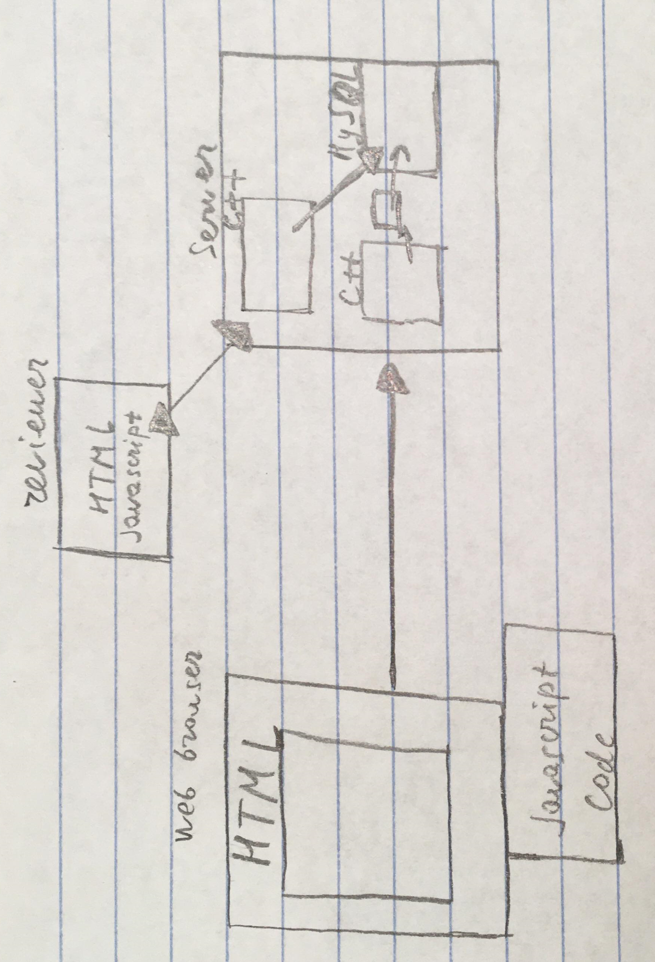**

1. **Size and Performance**

Number of use cases implemented: 2

1. **Quality**

The following quality goals have been identified:

**Security**

* **Description:** Mechanisms of authentication and authorization of users.
* **Solution:** C++ script is employed in the server to check if the reviewer is authorized.

**Reliability, availability**

* **Description:** The risk of system errors is minimized.
* **Solution:** Simplicity of code minimizes the risk of fatal errors.

**Performance**

* **Description:** Ability for the system to run fast and efficiently.
* **Solution:** Design the database with as little redundancy as possible, design the C++ and JavaScript code efficiently so that communication between the server and users is fast.

1. **References**Sommerville, Ian. *Software Engineering*. Pearson, 2018.